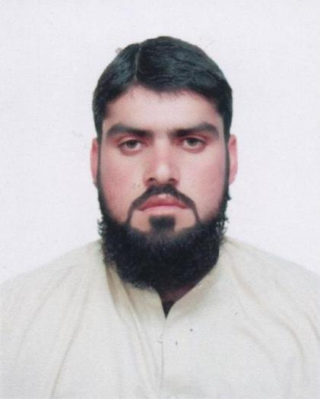
Curriculum Vitea

Fareed Ullah
Mobile # 050-5672644
Email: fareedafridi77@yahoo.com

========================================================

Career Objectives:
To work in an environment that can provide me an opportunity to expand my experience to develop my skills to enhance my knowledge at the same time to make use of my potentials in a professional atmosphere.

Professional Qualification:

FAC from government collage of technology Kohat Pakistan

Work experience

Recently working as Forman cum Driver with Cheyas Contracting LLC Dubai, UAE. I have 4 years experience for security job in Pakistan

Computer Skills:

- Microsoft –Windows Xp
- Microsoft – Office Xp (word, Excel, Power Point Etc)

License Details (3)
- License No : 1786367
- Issue date :03/05/2012
- Expiry date : 03/05/2022
- Place of issue :Dubai

Personal Strengths:
- Honest and Hardworking
- Dedication and reliability

Personal information:
Father Name : Malik Laiq Shah
Date of birth : 30th April 1991
Visa Status : Employment
Gender : Male
Religion : Islam
Marital Status : Single
Nationality : Pakistani
Language Known : English, Urdu and Pashto.

Others Qualities:
- Excellent Health
- Good Communication
- Interpersonal skills

Passport detail:

Passport No : AU8973401
Date of issue : 17th Sep 2009
Date of expiry : 17th Sep 2014
Place of issue : Pakistan

Conclusion:

I hereby declare that the above information and details are true and correct to the best of my knowledge and belief. Fareed Ullah

